13.Write a Pandas program to detect missing values of a given DataFrame. Display True or False.
Aim
To write a Pandas program to detect missing values in a given DataFrame and display the result as True for missing values and False for non-missing values.
Algorithm
- Import the required libraries: pandas and numpy.
- Create a DataFrame containing sample data with some missing (NaN) values.
- Display the original DataFrame.
- Use the isnull() method to check each element in the DataFrame for missing values.
- Display the output, where True indicates a missing value and False indicates a valid value.
PROGRAM
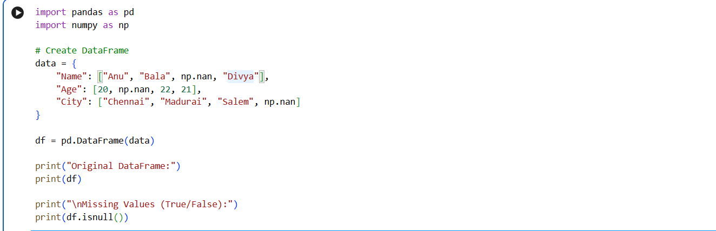
OUTPUT:
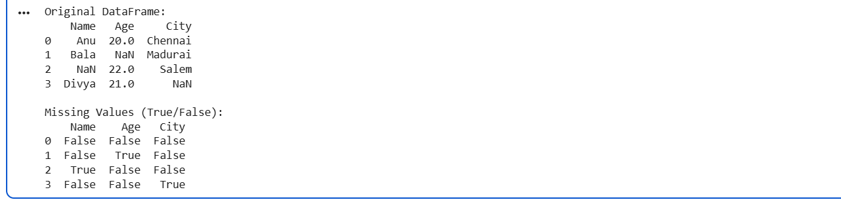
Result
The program successfully detected all the missing values in the given DataFrame. The isnull() method displayed True for the cells containing missing values and False for the cells containing valid data, making it easy to identify incomplete records.
14. Write a Pandas program to find and replace the missing values in a given DataFrame which do not have any valuable information.
Aim
To write a Pandas program to identify the missing values in a DataFrame and replace them with appropriate default values using the fillna() method.
Algorithm
- Import the required libraries: pandas and numpy.
- Create a DataFrame containing sample data with missing (NaN) values.
- Display the original DataFrame.
- Identify the missing values using the isnull() method (optional).
- Replace the missing values using the fillna() method with suitable values such as "Unknown", 0, or "Not Available".
- Display the updated DataFrame after replacing the missing values.
PROGRAM:
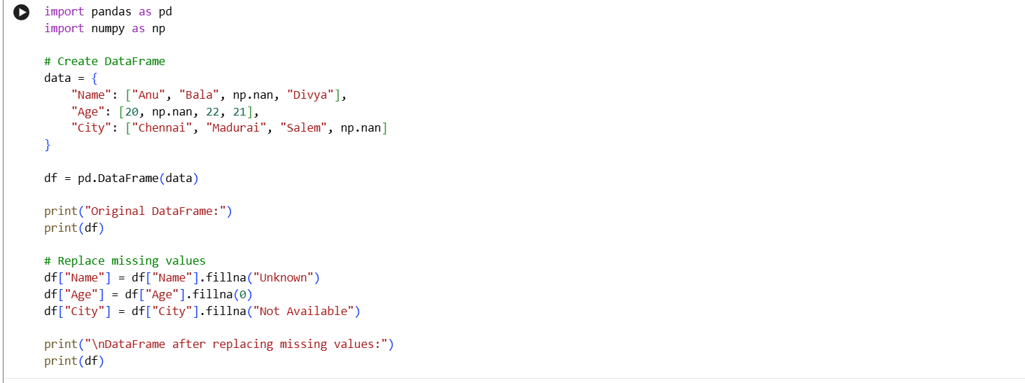
OUTPUT:
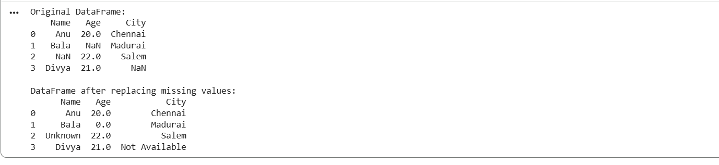
Result
The program successfully identified and replaced all the missing values in the DataFrame using the fillna() method. The updated DataFrame contained meaningful replacement values instead of NaN, resulting in a complete dataset that is easier to analyze and process.

